Phoenix ELN: MariaDB/MySQL Server Install Guide

# Introduction

*Phoenix ELN* optionally allows to synchronize its local database with a server database, resulting inbackup, data sharing, and central storage - some of the key benefits of an electronic lab notebook. *Phoenix ELN* supports the widely used open-source database management systems *MariaDB* and *MySQL* for server data storage.

# Server Hardware

For communities not having access to a *MySQL* or *MariaDB* installation on a corporate server, a NAS server box may be an excellent alternative. A NAS server is basically a robust Linux mini-PC designed for 24/7 use, configurable via an intuitive, web browser-based UI and available from less than USD 300 on. It can be plugged into your LAN just like any other PC and consumes little energy. The vast majority comes with either *MySQL* already pre-installed, but increasingly with the compatible *MariaDB*.

# Preparing for Phoenix ELN Database Creation

When *MySQL* or *MariaDB* are pre-installed on a NAS server, which is usually the case, this may not be visible directly in their interface (or even mentioned in the specifications) - you will need a database administration tool to access them within the server environment. Usually this is a tool called *phpMyAdmin*, which either is pre-installed or comes as a one-click installation package, available from the NAS interface. You can also use a tool like *HeidiSQL* to access the database from your PC, which is sometimes more convenient.

The installation on a corporate server occurs in analogy to the NAS procedure described above.

When first running one of these tools, a database connection is requested: Specify the server as “localhost”, the username as “root”, and create a password for accessing the database as administrator.

Once connected to the server, the next step is to create the *Phoenix ELN* database using the supplied database installation script (see section 4 below).

* Using *phpMyAdmin:* Go to the Home section, then click the “Import” button on the toolbar.   
    
  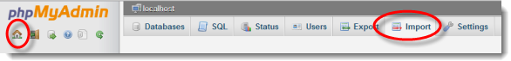
* Using *HeidiSQL:* For importing the supplied database installation script (see below), click the “Open SQL …” button in the *HeidiSQL* main toolbar.  
    
  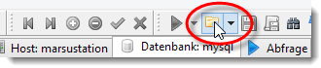

# Creating the Phoenix ELN Server Database

The *Phoenix ELN* server package contains the database script “PhoenixData_**Setup**_V.x.x.sql” for creating the server database. Open this script from *phpMyAdmin* or *HeidiSQL* from the import functionalities as described in the previous section. When loaded, click the appropriate “Run” or “Execute” button to start the script execution. After successful completion, your administration tool should display the new “PhoenixElnData” database and its tables – you may need to refresh the view of the tool to see it.

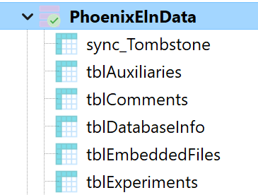

# Creating a User Account

The next step is to create a database user account for connecting the *Phoenix ELN* clients to the database.

In *HeidiSQL,* follow these *steps* to create a new user role: Go to *Tools -> User Manager* andclick the *New* toolbar button in the appearing user management window. This creates a new user. Please note that the username is *required* to be exactly **PhoenixUser** to be recognized by Phoenix ELN. Then specify a password of your choice and the desired *From Host* setting, where you can choose if the user account can access the database from your local network only (intranet), or additionally from outside (internet). Please note that access from the internet increases security risks. Finally assign exactly following access rights to the new user, by checking the appropriate checkboxes:

* Select
* Alter
* Create
* Delete
* Insert
* Update
* Super (-> required for assigning sufficient connection transaction memory to the client)

After saving this user login, the database setup is complete.

# Connecting Phoenix ELN

Now you are ready to connect *Phoenix ELN* clients: Run *Phoenix ELN* and click Tools > Server Connection item of the main toolbar, which will display the server login dialog:

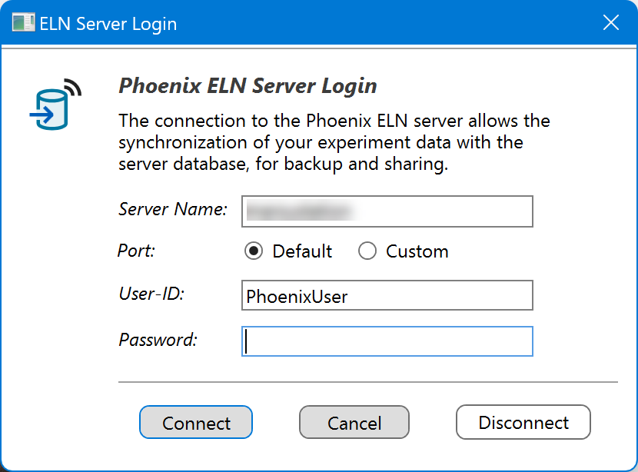

Enter the following connection data:

* **Server Path**: The machine name or IP address of your Phoenix ELN server (as visible in the ‘Network Connections’ node of Windows Explorer).
* **Port:** The server port normally should be left at the 'Default' option (this is port 3306). In special cases, e.g. when running two database versions in parallel, you may assign another port number by selecting the 'Custom' option.
* **User-ID / Password**: The required user-ID and password are *the same* for all Phoenix ELN users in your organization, where the user-ID always is 'PhoenixUser'. The global user access password is the one specified in the previous section, and also remains the same for all users. This should not be confused with the personal ELN user name and password utilized for finalizing experiments etc. The entered login data will be remembered when opening the application next time (the password is stored locally).

In case of **connection problems**, make sure that the server is visible in the Network Connection node of the *Windows Explorer* on the client – otherwise troubleshoot until visible to the LAN. Also consider to temporarily switch off your firewall(s) to determine if this is the cause of the issue.

If the connection was successful, the client will perform an initial upload of its local experiment database, if not in demo experiments mode. Afterwards it will start to auto-synchronize all changes to the server database.

# Automatic Schema Upgrades

New releases of the *Phoenix ELN* application sometimes may include changes to the required server database schema. To minimize the database maintenance overhead, the server database is always auto-upgraded by the first connecting client requiring the change. Such schema upgrades only include additions of columns or tables and therefore always keep the database backward compatible.

# Backup & Security

1. Regularly **back up** your server database.
2. If not necessary, don’t open your server for internet access, to **keep your data in-house**.

# Disclaimer

Please note that the maintainers of this open-source project cannot provide any support for server installation issues beyond this document. Please consult the *MySQL* or *MariaDB* forums for support in case of problems. Also, this guide was created with the best of knowledge, but is provided “as is”, with no warranties of any kind.